# Group 16 Project Emotional Analysis

## 4 Keys 2 Fun

### Hard Fun

Hard fun is offered through not only the conventional challenge typically seen in Rouge-like games, but also through the difficulty in mastering the core knock-back based movement mechanic. Moreover, due to the lack of permeance offered by the game, success in a ‘run’ of the game is determined almost entirely though player skill – this consequentially gives clear feedback to the player in regards to how far they are progressing through the learn, practice, master loop.

### Easy Fun

Elements of easy fun are present and expressed through the curiosity driven exploration of the procedurally-generated dungeons, as well as through exploring the game’s unique core movement system.

### People Fun

Light elements of people fun are present through the games’ local scoreboard system.

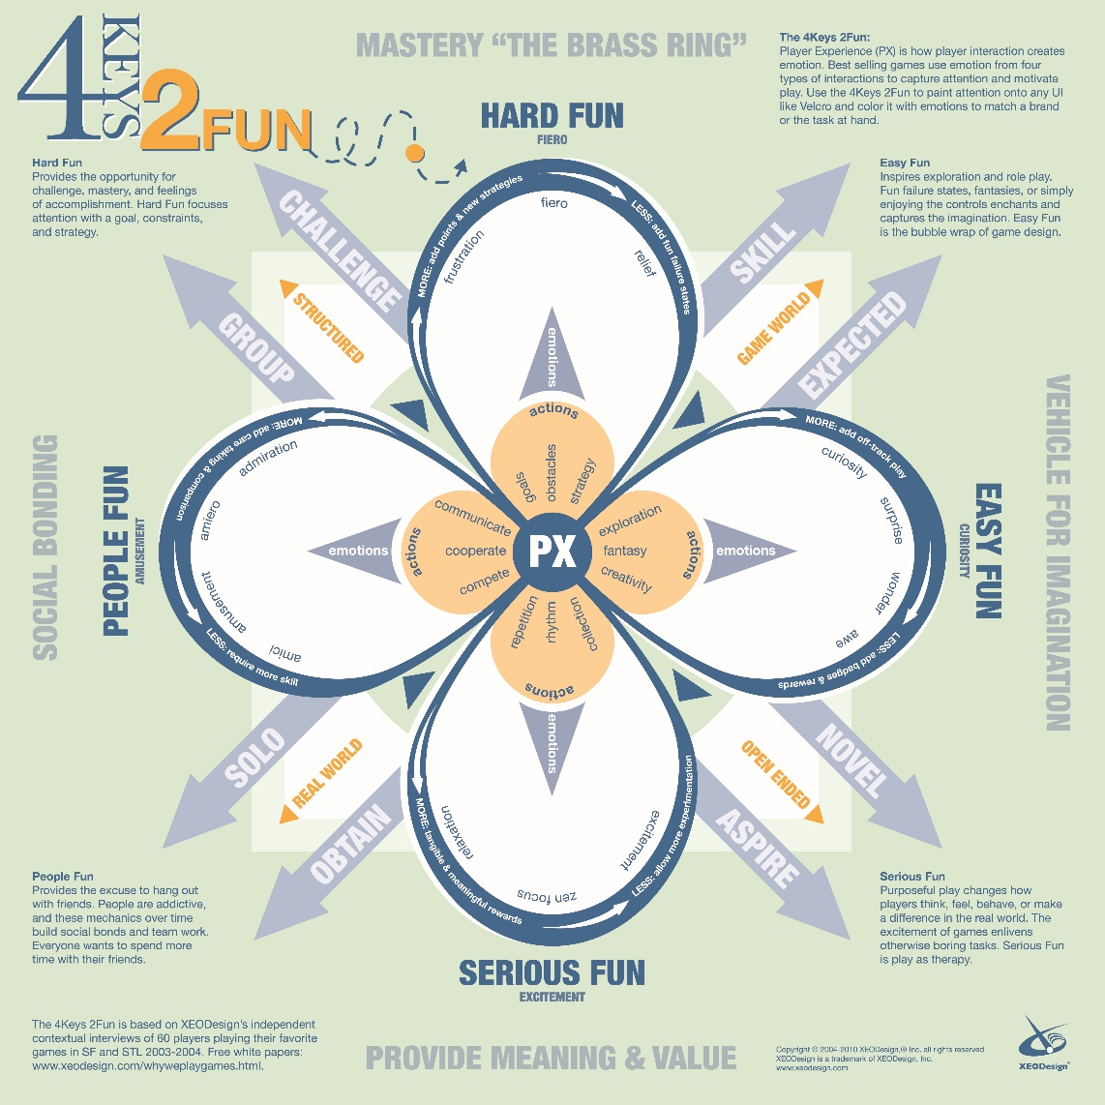

Figure 1 - A visual representation of the 4 Keys 2 Fun Model

## Fiero

Fiero is expressed as the game escalates to a point of climax along the dramatic arc – this is primarily driven by an escalation of difficulty over time, thereby increasing uncertainty.

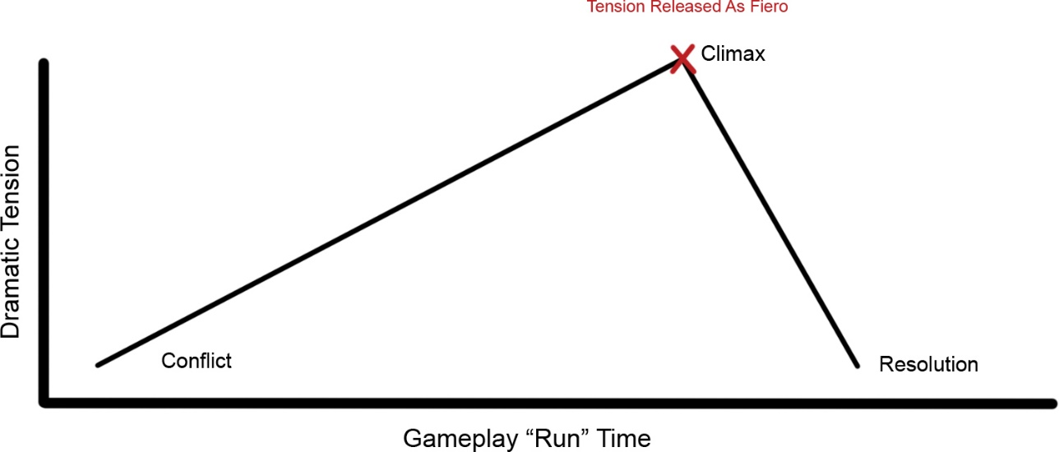

Figure 2 - An Illustration of Fiero Release Plotted Along the Dramatic Arc